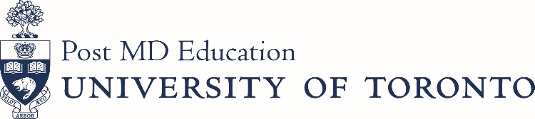

Postgraduate Administrator Advisory Committee (PAAC)
Date: January 12, 2021
Time: 12:30pm – 2:00pm
Meeting ID: 832 3951 7310; Passcode: e6pSni
AGENDA

Agenda/Minutes

Agenda Approval B. Baumgart For Approval

Approval of Minutes B. Baumgart For Approval

Business Arising from Last Meeting

Standing Items

Subcommittees

Appreciation & Recognition of the PA Event B. Baumgart For Discussion

Strengthening Partnerships D. Markovic/S. Santhirasiri For Discussion

PGMEAC B. Baumgart For Discussion

Hospital Onboarding B. Abankwah For Discussion

PAAC Awards M. Bidhendi For Discussion

Spotlight M. Bidhendi For Discussion

Recruitment-Policy for Review B. Baumgart For Discussion

New Business

Post-Accreditation Review

Open Forum

Next Meeting: March 9, May 11,

