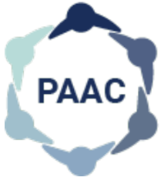

Postgraduate Administrator Advisory Committee (PAAC)
Date: March 22, 2022
Time: 12:30 pm – 1:30 pm

Location: Virtual by Zoom

Login Details: https://utoronto.zoom.us/j/81575245692 Meeting ID: 815 7524 5692; Passcode: 797103

AGENDA

Welcome

Welcome S. Clancey For Information

Agenda/Minutes

Agenda Approval S. Clancey For Approval

Approval of Minutes S. Clancey For Approval

Business Arising from Last Meeting

Recruitment for Secretary Position S. Clancey Report

Accreditation update L.L. Murgaski Report

Standing Items

Admin Series Subcommittee Updates

Feedback from Recent Sessions S. Clancey For Discussion

Tips and Tricks J. Tomac/D. Rodrigues Report

General Information M. Bidhendi Report

Continuing Education/Professional Development S. Clancey Report

Wellness B.Baumgart/K. Mintz Report

PAAC Awards M. Bidhendi For Approval

Strengthening Partnerships S. Santhirasiri Report

Hospital Onboarding B. Abankwah Report

PGMEAC Update S. Clancey Report

New Business

Terms of Reference Review S. Clancey For Review

Open Forum

Next Meeting: April 26, 2022 (virtual)

