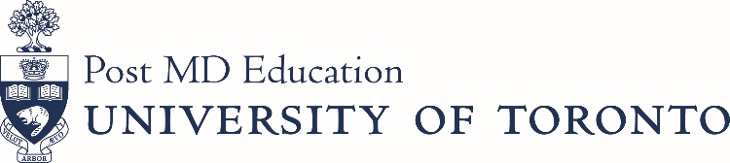

Postgraduate Administrator Advisory Committee (PAAC)
Date: Tuesday November 13, 2018
Time: 12:00pm – 2:00pm

500 University Avenue, 6th Floor Boardroom
AGENDA

Agenda/Minutes

Agenda Approval B. Abankwah For Approval

Approval of Minutes B. Abankwah For Approval

Business Arising from Last Meeting

Standing Items

Subcommittees

Appreciation Event Lisa Bevacqua/ For Discussion

Amy Widdifield

Communication Tool Update Paula Nixon For Discussion

New Business

Terms of Reference Refresh Bryan Abankwah For Discussion

Work plan and refresh

Committee membership Committee Members For Discussion

Dissemination of Info from PAAC to PAs Committee Members For Discussion

Open Forum

Next Meeting: TBD

