Zoom Meeting Instructions

Table of Contents | Page
Getting Started | 2
Creating an Account and Logging in | 2
Profile and Settings | 3
Waiting Room | 3
Disabling Chat | 4
Assigning Co-Host | 5
Scheduling Meeting | 6
Inviting Participants | 7
Day of Meeting | 7
Start the Meeting | 7
Admitting Participants | 8
Assigning new host and leaving meeting | 9
Additional Information | 9

Getting Started: Creating an Account and Logging in
- NOTE: You will need to have a paid account as the basic account does not have adequate features for the Accreditation Meetings.

- Please check with your Program or Department to see if you have access to a paid Zoom account.

- If you have a UTORid, you can also access the UofT provided paid accounts by visiting utoronto.zoom.us and selecting Log in to Zoom on the bottom right.

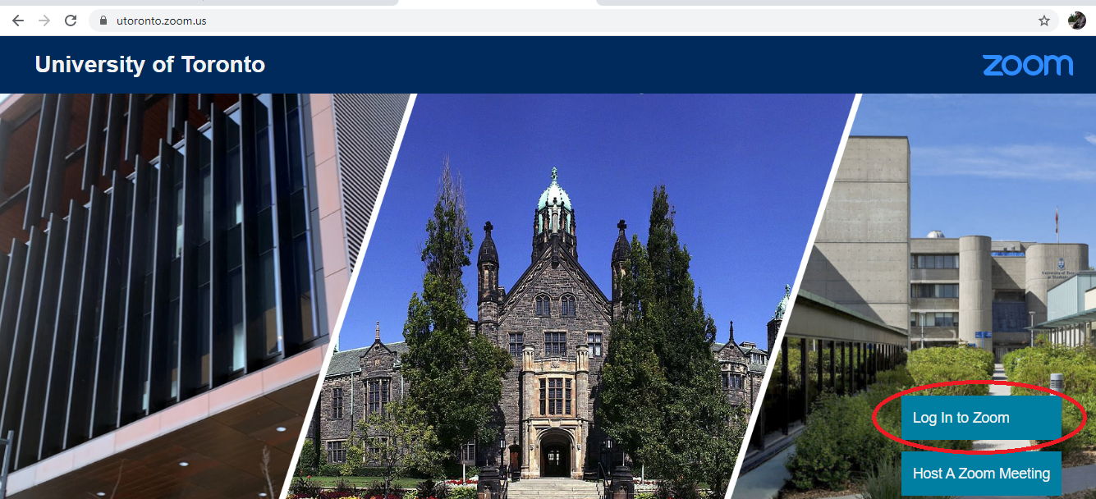

- This will direct you to the UTORauth page where you can enter your UTORid and password and will be granted access to a paid account with unlimited meeting lengths.

- If you do not have a UTORid or paid Zoom account, you can sign up for an account by visiting zoom.us/signup and following the instructions.

Profile and Settings
- Once you have logged in, you will be directed to your Profile landing page as shown below.
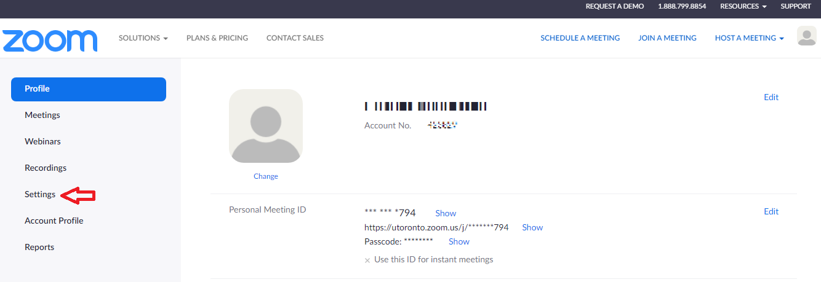
- From here you can edit your profile and meeting settings by using the navigation menu on the left.

- Select the Settings tab to configure three important meeting features: waiting room, chat feature and co-hosts.
Waiting Room
- From the Setting tab, please ensure that the Waiting Room feature is enabled. This feature allows the host to admit each meeting participant individually.
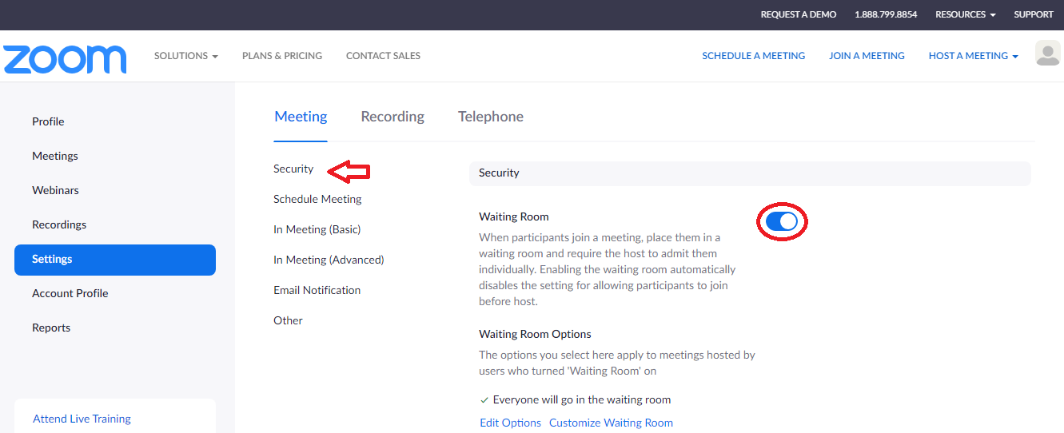

- Under the Meeting tab, select Security, the Waiting Room will be the first feature that appears.

- Ensure that the toggle, circled above, is to the right and shown in blue. This indicates that the Waiting Room is enabled.
Disabling Chat:
- From the Setting Tab, please disable the chat feature to prevent participants from sending messages to others.

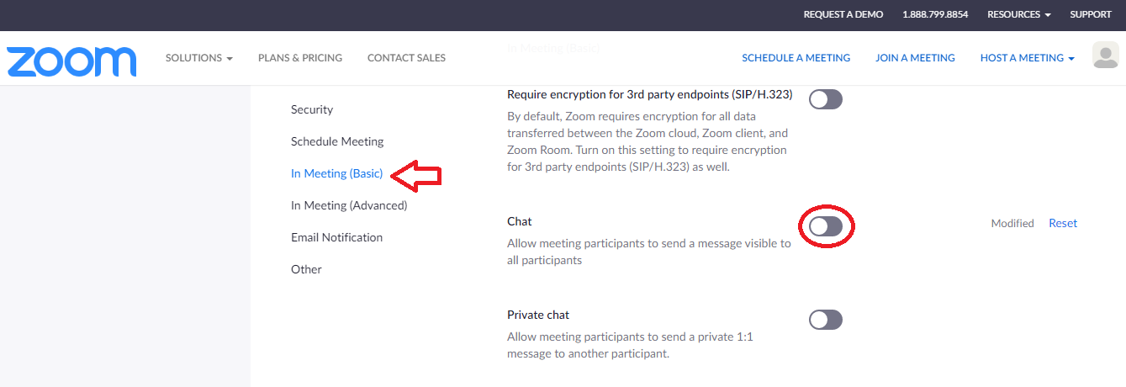
- Select In Meeting (Basic) and find the Chat feature.

- Ensure that the toggle, circled above, is to the right and in gray. This indicates that the feature is disabled.

Note: The chat feature can also be disabled on the day of the meeting
- If you need to disable the chat feature once the meeting has already started, select the ellipses icon at the bottom of the chat panel

- Select the Participants Can Chat With “no one” option
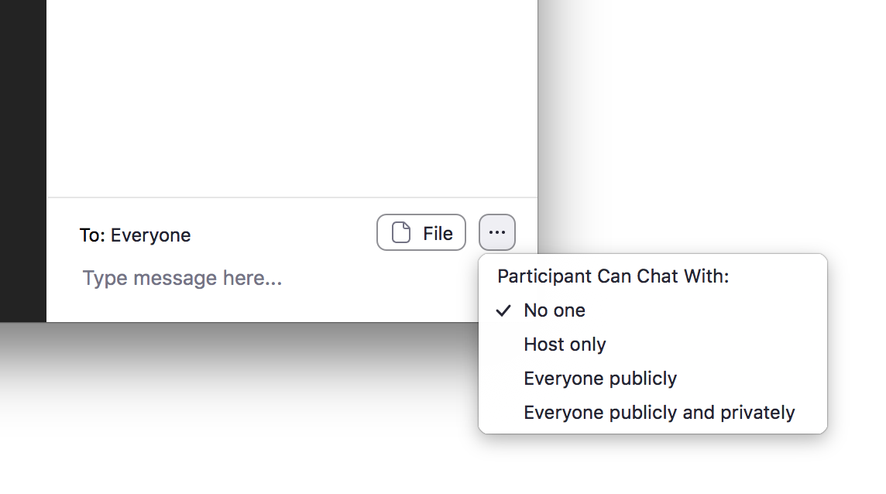
Assigning Co-host
- Ensure that the Co-host feature is enabled so that you can assign full host abilities to the Surveyors when the meeting begins.
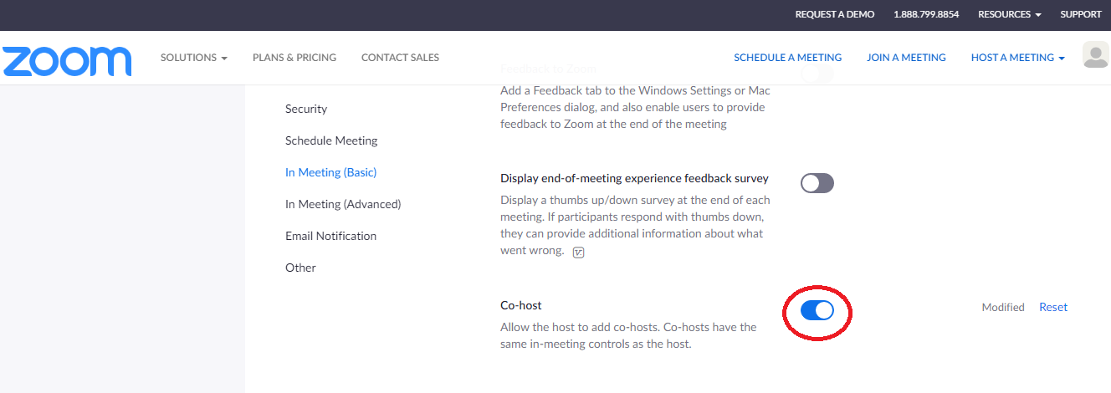
- This feature is found in the In Meeting (Basic) tab, seven features below Chat.

- Ensure that the toggle, circled above, is to the right and shown in blue. This indicates that the Co-host feature is enabled.

Scheduling Meetings:
- Please note that the Program will be responsible for organizing the Zoom meeting link. This will be added to the top of your schedule and shared with the participants.

- A reminder that all meetings throughout the day will use the same link, and the Surveyors will use the Waiting Room feature to let participants in and out.

- To generate a link, select Schedule a Meeting from the top right of the page.
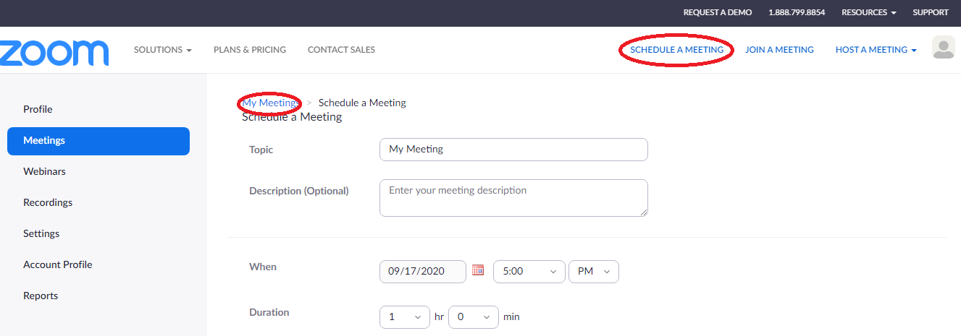

- From here you must fill out all of the relevant Accreditation Visit information and select Save at the bottom of the page.

- Afterwards, navigate to the My Meetings page, which will be on the top left of the next page and you will be directed to a page displaying all of your upcoming meetings. Find and select the meeting that you have just created.

Inviting Participants:
- You will be able to find the Invite Link and accompanying password midway down the page. This information will be added as a header to the Accreditation Visit Schedule that will be shared with the Surveyors and Participants.

- You can use the copy invitation button to copy the relevant meeting details to your clipboard so that you can paste them directly into the email you send inviting participants for each meeting.
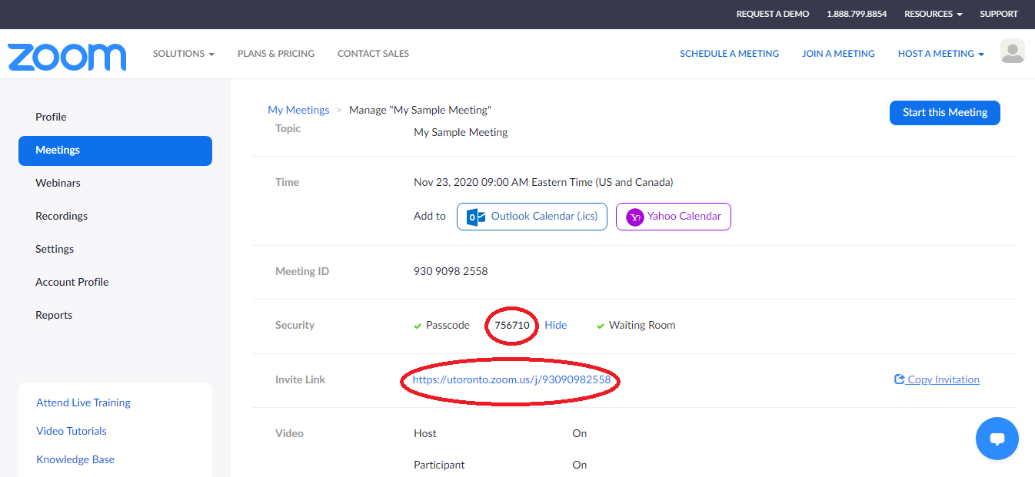

Day of Meeting: Start the Meeting
- On the day of your program / site’s review, login to your account, select Meetings from the menu and press the select the Start button to begin the meeting.
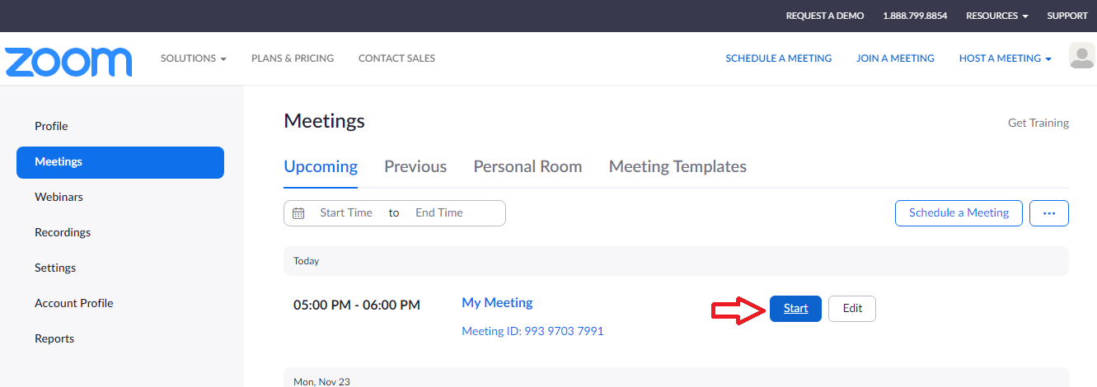

Admitting Participants
- As host, you will need to admit the survey team members (and any Royal College or CFPC Staff members) to the meeting and transfer the hosting duties to surveyors.
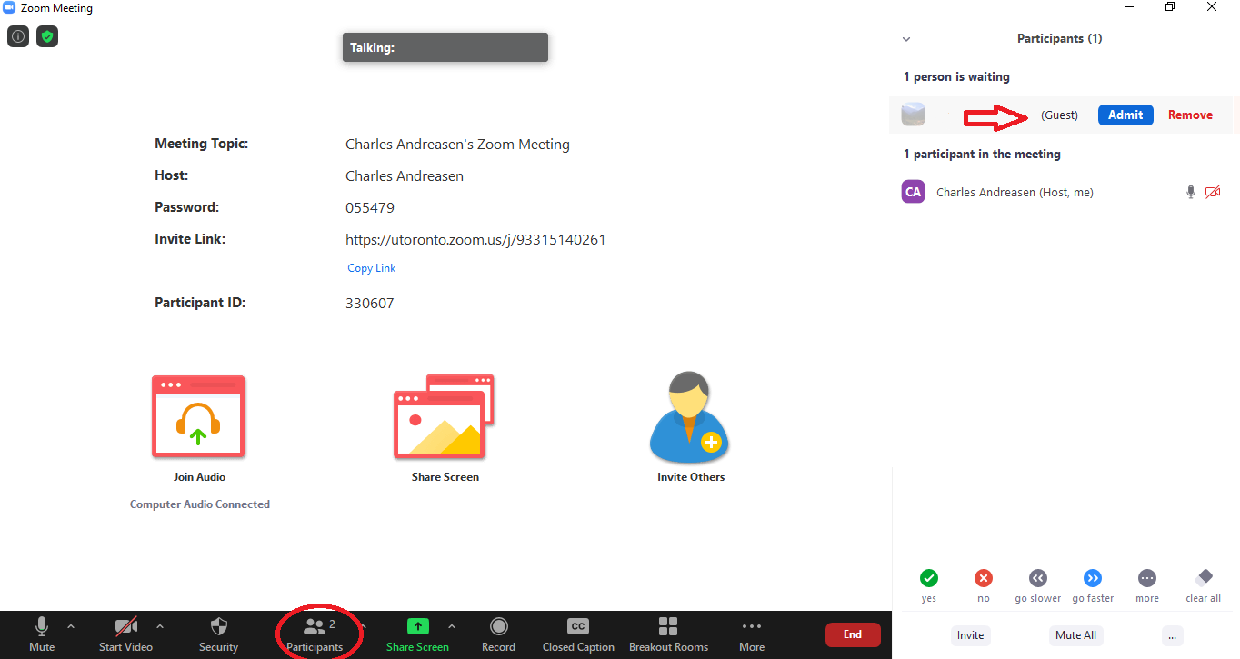
- To admit users, select Participants from the bottom menus. When the Participants menu appears on the right, select Admit beside the participant’s name.

Assigning a co-host
- To pass hosting duties over to a different participant, move your cursor over their video feed and a Mute button and an ellipses will appear.
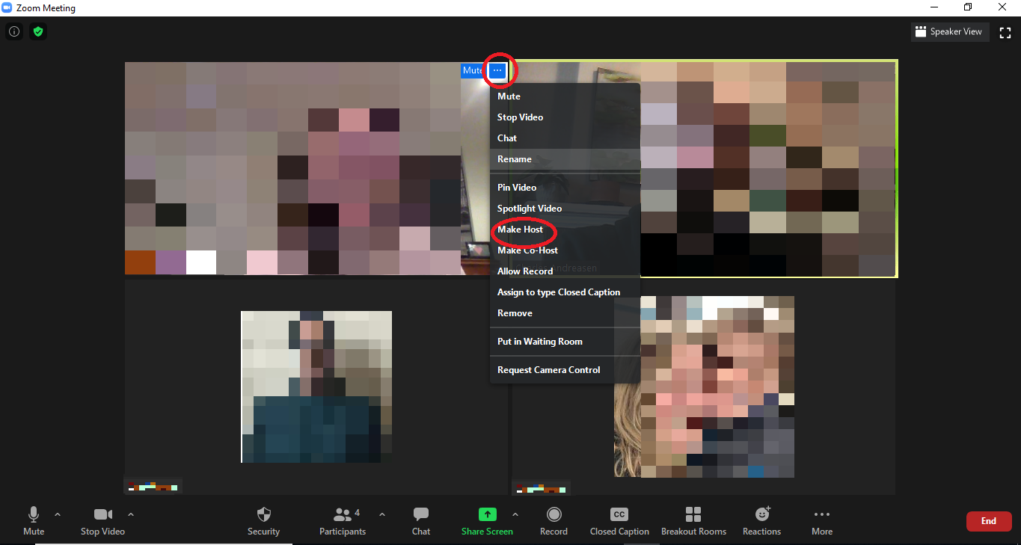
- Select the ellipses to make a drop down menu appear.

- Select the Make Host option.

- To leave the meeting, select the End button in the bottom right. When the following options appear, select Leave Meeting.
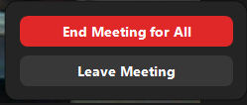

Additional Information:
- You can find more information on Zoom by visiting their support page: https://support.zoom.us/.
- If you have any questions or require further information about the upcoming Accreditation visit, please email pgmecoordinator@utoronto.ca.

